Refer to the figure below.
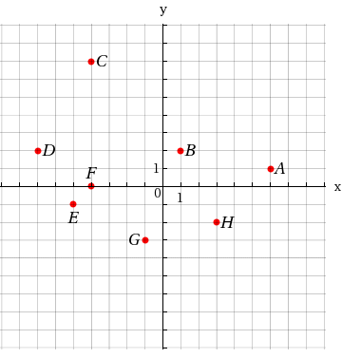
Find the coordinates of the points shown.
Point A (x, y) | = | 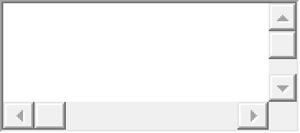
Point B (x, y) | =
Point C (x, y) | =
Point D (x, y) | =
Point E (x, y) | =
Point F (x, y) | =
Point G (x, y) | =
Point H (x, y) | =


2.
[–/2 Points]DETAILSSPRECALC7 1.9.012.
MY NOTES
PRACTICE ANOTHER
Refer to the figure below.
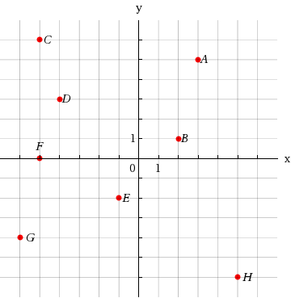
Select the points that lie in Quadrant I. (Select all that apply.)
ABCDEFGH
Select the points that lie in Quadrant III. (Select all that apply.)
ABCDEFGH



3.
[–/2 Points]DETAILSSPRECALC7 1.9.023.
MY NOTES
PRACTICE ANOTHER
A pair of points is graphed.
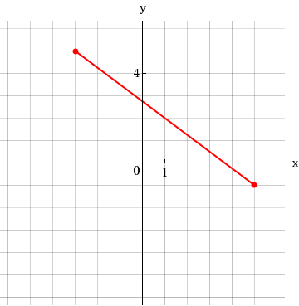
(a) Find the distance between them.

(b) Find the midpoint of the segment that joins them.
(x, y) =

4.
[–/2 Points]DETAILSSPRECALC7 1.9.024.
MY NOTES
PRACTICE ANOTHER
A pair of points is graphed.
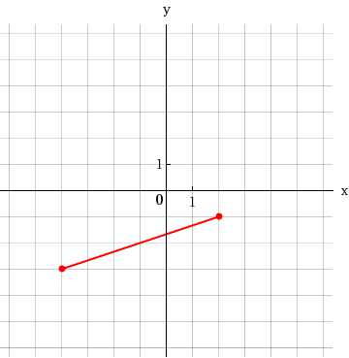
(a) Find the distance between them.

(b) Find the midpoint of the segment that joins them.
(x, y) =

A line has the equation
y = 7x + 2.
(a) This line has slope  .
(b) Any line parallel to this line has slope .
(c) Any line perpendicular to this line has slope .

2.
[–/1 Points]DETAILSSPRECALC7 1.10.003.
MY NOTES
PRACTICE ANOTHER
The point-slope form of the equation of the line with slope 6 passing through the point (1, 2) is

.

3.
[–/2 Points]DETAILSSPRECALC7 1.10.006.
MY NOTES
PRACTICE ANOTHER
The slope of a vertical line is  . The equation of the vertical line passing through
(9, 5)
is

.

4.
[–/1 Points]DETAILSSPRECALC7 1.10.009.
MY NOTES
PRACTICE ANOTHER
Find the slope of the line through P and Q.
P(−1, 2), Q(0, 0)

5.
[–/1 Points]DETAILSSPRECALC7 1.10.010.
MY NOTES
PRACTICE ANOTHER
Find the slope of the line through P and Q.
P(0, 0), Q(3, −2)

6.
[–/1 Points]DETAILSSPRECALC7 1.10.011.
MY NOTES
PRACTICE ANOTHER
Find the slope of the line through P and Q.
P(5, −5), Q(8, −1)

7.
[–/1 Points]DETAILSSPRECALC7 1.10.012.
MY NOTES
PRACTICE ANOTHER
Find the slope of the line through P and Q.
P(−2, 1), Q(7, −2)

8.
[–/1 Points]DETAILSSPRECALC7 1.10.013.
MY NOTES
PRACTICE ANOTHER
Find the slope of the line through P and Q.
P(8, 9), Q(0, 9)

9.
[–/1 Points]DETAILSSPRECALC7 1.10.014.
MY NOTES
PRACTICE ANOTHER
Find the slope of the line through P and Q.
P(9, 2), Q(1, −1)

10.
[–/1 Points]DETAILSSPRECALC7 1.10.015.
MY NOTES
PRACTICE ANOTHER
Find the slope of the line through P and Q.
P(17, −1), Q(7, −2)
Find an equation for the line whose graph is sketched.

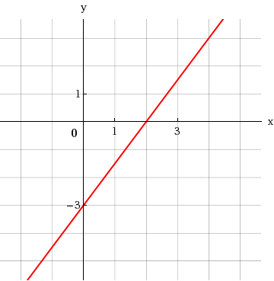

2.
[–/1 Points]DETAILSSPRECALC7 1.10.022.
MY NOTES
PRACTICE ANOTHER
Find an equation for the line whose graph is sketched.

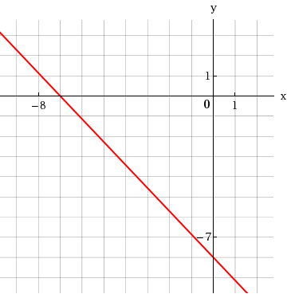

3.
[–/1 Points]DETAILSSPRECALC7 1.10.023.MI.
MY NOTES
PRACTICE ANOTHER
Find an equation of the line that satisfies the given conditions.
Slope 10; y-intercept −1

4.
[–/1 Points]DETAILSSPRECALC7 1.10.024.MI.
MY NOTES
PRACTICE ANOTHER
Find an equation of the line that satisfies the given conditions.
Slope
4
7
; y-intercept 8

5.
[–/1 Points]DETAILSSPRECALC7 1.10.025.MI.
MY NOTES
PRACTICE ANOTHER
Find an equation of the line that satisfies the given conditions.
Through (4, 2); slope 5

6.
[–/1 Points]DETAILSSPRECALC7 1.10.026.MI.
MY NOTES
PRACTICE ANOTHER
Find an equation of the line that satisfies the given conditions.
Through (−4, 7); slope −1

7.
[–/1 Points]DETAILSSPRECALC7 1.10.027.MI.
MY NOTES
PRACTICE ANOTHER
Find an equation of the line that satisfies the given conditions.
Through (3, 8); slope
2
3

8.
[–/1 Points]DETAILSSPRECALC7 1.10.029.
MY NOTES
PRACTICE ANOTHER
Find an equation of the line that satisfies the given conditions.
Through (8, 7) and (7, 9)

9.
[–/1 Points]DETAILSSPRECALC7 1.10.031.
MY NOTES
PRACTICE ANOTHER
Find an equation of the line that satisfies the given conditions.
Through
(−2, 4) and (−1, −3)

10.
[–/1 Points]DETAILSSPRECALC7 1.10.032.
MY NOTES
PRACTICE ANOTHER
Find an equation of the line that satisfies the given conditions.
Through (5, 6) and (9, 6)

A linear function is given.
f(x) =
1
3
x + 8
(a) Find the average rate of change of the function between
x = a
and
x = a + h.

(b) Find the slope of the line.

2.
[–/2 Points]DETAILSSPRECALC7 2.4.026.MI.
MY NOTES
PRACTICE ANOTHER
A linear function is given.
g(x) = −8x + 7
(a) Find the average rate of change of the function between
x = a
and
x = a + h.

(b) Find the slope of the line.

3.
[–/3 Points]DETAILSSPRECALC7 2.4.028.
MY NOTES
Graphs of the functions f, g, and h are shown below. What can you say about the average rate of change of each function on the successive intervals
[0, 1], [1, 2], [2, 3], …?
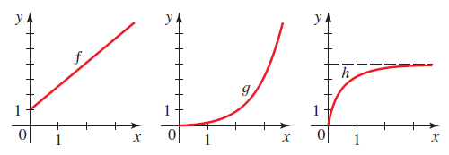
The average rate of change of f on the successive intervals is the following.
constantincreasing decreasing
The average rate of change of g on the successive intervals is the following.
constantincreasing decreasing
The average rate of change of h on the successive intervals is the following.
constantincreasing decreasing

4.
[–/2 Points]DETAILSSPRECALC7 2.4.021.MI.
MY NOTES
PRACTICE ANOTHER
A function is given.
g(x) =
7
x
; x = 1, x = a
(a) Determine the net change between the given values of the variable.

(b) Determine the average rate of change between the given values of the variable.

5.
[–/2 Points]DETAILSSPRECALC7 2.4.022.MI.
MY NOTES
PRACTICE ANOTHER
A function is given.
g(x) =
6
x + 9
; x = 0, x = h
(a) Determine the net change between the given values of the variable.

(b) Determine the average rate of change between the given values of the variable.

If a function f is an odd function, then what type of symmetry does the graph of f have?
The function f has symmetry with respect to the y-axis.The function f has symmetry with respect to the x-axis. The function f has symmetry with respect to the origin.

2.
[–/2 Points]DETAILSSPRECALC7 2.6.007.
MY NOTES
PRACTICE ANOTHER
Suppose the graph of f is given. Describe how the graph of each function can be obtained from the graph of f.
(a)
f(x) − 7

shift left 7 unitsshift right 7 units shift up 7 unitsshift down 7 unitsstretch vertically by a factor of 7
(b)
f(x − 4)

shift left 4 unitsshift right 4 units shift up 4 unitsshift down 4 unitsstretch vertically by a factor of 4

3.
[–/2 Points]DETAILSSPRECALC7 2.6.008.
MY NOTES
PRACTICE ANOTHER
Suppose the graph of f is given. Describe how the graph of each function can be obtained from the graph of f.
(a)
f(x + 3)

shift left 3 unitsshift right 3 units shift up 3 unitsshift down 3 unitsstretch vertically by a factor of 3
(b)
f(x) + 6

shift left 6 unitsshift right 6 units shift up 6 unitsshift down 6 unitsstretch vertically by a factor of 6

4.
[–/2 Points]DETAILSSPRECALC7 2.6.011.
MY NOTES
PRACTICE ANOTHER
Suppose the graph of f is given. Describe how the graph of each function can be obtained from the graph of f.
(a)
y = f(x − 9) + 2

shift 9 units to the left and 2 units downwardreflect about the x-axis, then shift 2 units upward shift 9 units to the right and 2 units upwardshift 2 units to the left and 9 units downwardshift 2 units to the right and 9 units upward
(b)
y = f(x + 3) − 1

shift 1 unit to the left and 3 units downwardshift 1 unit to the right and 3 units upward shift 3 units to the right and 1 unit upwardreflect about the y-axis, then shift 3 units to the leftshift 3 units to the left and 1 unit downward

5.
[–/2 Points]DETAILSSPRECALC7 2.6.012.
MY NOTES
PRACTICE ANOTHER
Suppose the graph of f is given. Describe how the graph of each function can be obtained from the graph of f.
(a)
y = f(x + 5) + 2

shift 2 units to the right and 5 units downwardshift 5 units to the left and 2 units upward shift 5 units to the left and 2 units downwardshift 2 units to the right and 5 units upwardshift 5 units to the right and 2 units upward
(b)
y = f(x − 4) − 3

shift 3 units to the right and 4 units downwardshift 4 units to the left and 3 units downward shift 4 units to the right and 3 units upwardshift 4 units to the right and 3 units downwardshift 3 units to the left and 4 units upward

6.
[–/2 Points]DETAILSSPRECALC7 2.6.013.
MY NOTES
PRACTICE ANOTHER
Suppose the graph of f is given. Describe how the graph of each function can be obtained from the graph of f.
(a)
y = −f(x) + 6

reflect about the x-axis, then shift down 6 unitsreflect about the x-axis, then shift up 6 units reflect about the y-axis, then shift down 6 unitsreflect about the y-axis, then shift up 6 unitsreflect about the y-axis, then shift left 6 units
(b)
y = 2f(x) − 6

shift down 6 units, then stretch vertically by a factor of 2stretch vertically by a factor of 6, then shift down 2 units stretch vertically by a factor of 2, then shift down 6 unitsstretch vertically by a factor of 2, then shift up 6 unitsshrink vertically by a factor of 2, then shift down 6 units

7.
[–/2 Points]DETAILSSPRECALC7 2.6.015.
MY NOTES
PRACTICE ANOTHER
Suppose the graph of f is given. Describe how the graph of each function can be obtained from the graph of f.
(a)
4f(x + 8) − 1

shift 8 units to the left, shrink vertically by 4, then shift downward 1 unitshift 8 units to the left, stretch vertically by 4, then shift downward 1 unit shift 8 units to the right, shrink vertically by 4, then shift downward 1 unitshift 8 units to the left, stretch vertically by 4, then shift upward 1 unitshift 8 units to the right, stretch vertically by 4, then shift downward 1 unit
(b)
1
4
f(x − 5) + 8

shift 5 units to the right, stretch vertically by 1/4, then shift upward 8 unitsshift 5 units to the right, shrink vertically by 1/4, then shift downward 8 units shift 5 units to the right, shrink vertically by 1/4, then shift upward 8 unitsshift 5 units to the left, shrink vertically by 1/4, then shift upward 8 unitsshift 5 units to the left, stretch vertically by 1/4, then shift upward 8 units

8.
[–/2 Points]DETAILSSPRECALC7 2.6.016.
MY NOTES
PRACTICE ANOTHER
Suppose the graph of f is given. Describe how the graph of each function can be obtained from the graph of f.
(a)
1
3
f(x − 5) + 4

shift 5 units to the left, shrink vertically by 1/3, then shift upward 4 unitsshift 5 units to the right, shrink vertically by 1/3, then shift downward 4 units shift 5 units to the right, stretch vertically by 1/3, then shift upward 4 unitsshift 5 units to the right, shrink vertically by 1/3, then shift upward 4 unitsshift 5 units to the left, stretch vertically by 1/3, then shift upward 4 units
(b)
4f(x + 1) + 9

shift 1 unit to the right, shrink vertically by 4, then shift upward 9 unitsshift 1 unit to the right, stretch vertically by 4, then shift upward 9 units shift 1 unit to the left, shrink vertically by 4, then shift upward 9 unitsshift 1 unit to the left, stretch vertically by 4, then shift downward 9 unitsshift 1 unit to the left, stretch vertically by 4, then shift upward 9 units
Find
f + g,

f − g,

fg,
and
f/g
and their domains.
f(x) = x, g(x) = 8x
Find
(f + g)(x).

Find the domain of
(f + g)(x).
(Enter your answer using interval notation.)

Find
(f − g)(x).

Find the domain of
(f − g)(x).
(Enter your answer using interval notation.)

Find
(fg)(x).

Find the domain of
(fg)(x).
(Enter your answer using interval notation.)

Find

f
g

(x).

Find the domain of

f
g

(x).
(Enter your answer using interval notation.)

2.
[–/8 Points]DETAILSSPRECALC7 2.7.008.
MY NOTES
Find
f + g,

f − g,

fg,
and
f/g
and their domains.
f(x) = x, g(x) =
x
Find
(f + g)(x).

Find the domain of
(f + g)(x).
(Enter your answer using interval notation.)

Find
(f − g)(x).

Find the domain of
(f − g)(x).
(Enter your answer using interval notation.)

Find
(fg)(x).

Find the domain of
(fg)(x).
(Enter your answer using interval notation.)

Find

f
g

(x).

Find the domain of

f
g

(x).
(Enter your answer using interval notation.)

3.
[–/8 Points]DETAILSSPRECALC7 2.7.009.
MY NOTES
Find
f + g,

f − g,

fg,
and
f/g
and their domains.
f(x) = x² + x, g(x) = x²
Find
(f + g)(x).

Find the domain of
(f + g)(x).
(Enter your answer using interval notation.)

Find
(f − g)(x).

Find the domain of
(f − g)(x).
(Enter your answer using interval notation.)

Find
(fg)(x).

Find the domain of
(fg)(x).
(Enter your answer using interval notation.)

Find

f
g

(x).

Find the domain of

f
g

(x).
(Enter your answer using interval notation.)

4.
[–/8 Points]DETAILSSPRECALC7 2.7.010.
MY NOTES
PRACTICE ANOTHER
Find
f + g,

f − g,

fg,
and
f/g
and their domains.
f(x) = 2 − x², g(x) = x² − 9
Find
(f + g)(x).

Find the domain of
(f + g)(x).
(Enter your answer using interval notation.)

Find
(f − g)(x).

Find the domain of
(f − g)(x).
(Enter your answer using interval notation.)

Find
(fg)(x).

Find the domain of
(fg)(x).
(Enter your answer using interval notation.)

Find

f
g

(x).

Find the domain of

f
g

(x).
(Enter your answer using interval notation.)

5.
[–/8 Points]DETAILSSPRECALC7 2.7.011.
MY NOTES
PRACTICE ANOTHER
Find
f + g,

f − g,

fg,
and
f/g
and their domains.
f(x) = 4 − x, g(x) = x² − 3x
Find
(f + g)(x).

Find the domain of
(f + g)(x).
(Enter your answer using interval notation.)

Find
(f − g)(x).

Find the domain of
(f − g)(x).
(Enter your answer using interval notation.)

Find
(fg)(x).

Find the domain of
(fg)(x).
(Enter your answer using interval notation.)

Find

f
g

(x).

Find the domain of

f
g

(x).
(Enter your answer using interval notation.)

6.
[–/8 Points]DETAILSSPRECALC7 2.7.012.
MY NOTES
PRACTICE ANOTHER
Consider the following functions.
f(x) = x² + 5x, g(x) = 7x² − 1
Find
(f + g)(x).

Find the domain of
(f + g)(x).
(Enter your answer using interval notation.)

Find
(f − g)(x).

Find the domain of
(f − g)(x).
(Enter your answer using interval notation.)

Find
(fg)(x).

Find the domain of
(fg)(x).
(Enter your answer using interval notation.)

Find

f
g

(x).

Find the domain of

f
g

(x).
(Enter your answer using interval notation.)

7.
[–/8 Points]DETAILSSPRECALC7 2.7.013.
MY NOTES
PRACTICE ANOTHER
Find
f + g,

f − g,

fg,
and
f/g
and their domains.
f(x) =
36 − x²
, g(x) =
x + 2
Find
(f + g)(x).

Find the domain of
(f + g)(x).
(Enter your answer using interval notation.)

Find
(f − g)(x).

Find the domain of
(f − g)(x).
(Enter your answer using interval notation.)

Find
(fg)(x).

Find the domain of
(fg)(x).
(Enter your answer using interval notation.)

Find

f
g

(x).

Find the domain of

f
g

(x).
(Enter your answer using interval notation.)

Find the domain of the function. (Enter your answer using interval notation.)
k(x) =
x + 5

x − 4

2.
[–/2 Points]DETAILSSPRECALC7 2.7.028.MI.
MY NOTES
PRACTICE ANOTHER
Use
f(x) = 4x − 3
and
g(x) = 2 − x²
to evaluate the expression.
(a)
f(f(2))

(b)
g(g(3))

3.
[–/2 Points]DETAILSSPRECALC7 2.7.029.MI.
MY NOTES
PRACTICE ANOTHER
Use
f(x) = 4x − 3
and
g(x) = 2 − x²
to evaluate the expression.
(a)
(f ∘ g)(−2)

(b)
(g ∘ f)(−2)

4.
[–/2 Points]DETAILSSPRECALC7 2.7.030.MI.
MY NOTES
PRACTICE ANOTHER
Use
f(x) = 5x − 2
and
g(x) = 4 − x²
to evaluate the expression.
(a)
(f ∘ f)(−1)

(b)
(g ∘ g)(−1)

5.
[–/2 Points]DETAILSSPRECALC7 2.7.031.MI.
MY NOTES
PRACTICE ANOTHER
Use
f(x) = 4x − 2
and
g(x) = 5 − x²
to evaluate the expression.
(a)
(f ∘ g)(x)

(b)
(g ∘ f)(x)

6.
[–/2 Points]DETAILSSPRECALC7 2.7.032.
MY NOTES
PRACTICE ANOTHER
Use
f(x) = 3x − 2
and
g(x) = 4 − x²
to evaluate the expression.
(a)
(f ∘ f)(x)

(b)
(g ∘ g)(x)

7.
[–/1 Points]DETAILSSPRECALC7 2.7.036.MI.
MY NOTES
PRACTICE ANOTHER
Use the given graphs of f and g to evaluate the expression. (Assume that each point lies on the gridlines.)
(f ∘ g)(4) =
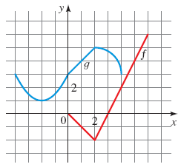

8.
[–/1 Points]DETAILSSPRECALC7 2.7.037.MI.
MY NOTES
PRACTICE ANOTHER
Use the given graphs of f and g to evaluate the expression. (Assume that each point lies on the gridlines.)
(g ∘ g)(1) =
A graph of a function f is given.
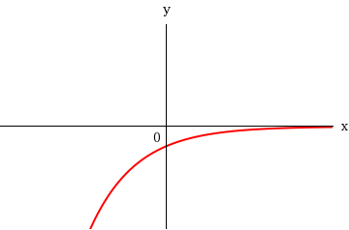
Determine whether f is one-to-one.
Yes, f is one-to-one.No, f is not one-to-one.

2.
[–/1 Points]DETAILSSPRECALC7 2.8.010.
MY NOTES
PRACTICE ANOTHER
A graph of a function f is given.
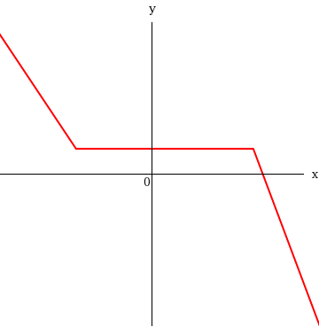
Determine whether f is one-to-one.
Yes, f is one-to-one.No, f is not one-to-one.

3.
[–/1 Points]DETAILSSPRECALC7 2.8.013.
MY NOTES
PRACTICE ANOTHER
Determine whether the function is one-to-one.
f(x) = −7x + 2
is one-to-oneis not one-to-one

4.
[–/1 Points]DETAILSSPRECALC7 2.8.050.MI.
MY NOTES
PRACTICE ANOTHER
Find the inverse function of f.
f(x) = 8 − 6x
f ⁻¹(x) =

5.
[–/1 Points]DETAILSSPRECALC7 2.8.051.
MY NOTES
PRACTICE ANOTHER
Find the inverse function of f.
f(x) = 5 − 8x³
f ⁻¹(x) =

6.
[–/1 Points]DETAILSSPRECALC7 2.8.052.
MY NOTES
PRACTICE ANOTHER
Find the inverse function of f.
f(x) = 2x³ + 1
f ⁻¹(x) =

7.
[–/1 Points]DETAILSSPRECALC7 2.8.053.MI.
MY NOTES
PRACTICE ANOTHER
Find the inverse function of f.
f(x) =
1
x + 8
f ⁻¹(x) =

8.
[–/1 Points]DETAILSSPRECALC7 2.8.055.
MY NOTES
PRACTICE ANOTHER
Find the inverse function of f.
f(x) =
x
x + 6
f ⁻¹(x) =

9.
[–/1 Points]DETAILSSPRECALC7 2.8.056.
MY NOTES
PRACTICE ANOTHER
Find the inverse function of f.
f(x) =
3x
x − 4
f ⁻¹(x) =

10.
[–/1 Points]DETAILSSPRECALC7 2.8.057.
MY NOTES
PRACTICE ANOTHER
Find the inverse function of f.
f(x)=
3x + 9
x − 5
f ⁻¹(x) =

The graph of a quadratic function f is given.
f(x) = 4x² + 8x − 3
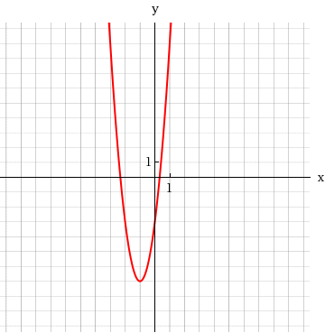
(a) Find the coordinates of the vertex and the x- and y-intercepts. (Round your answers to one decimal place.)
vertex |  | (x, y) | =
x-intercepts |  | (x, y) | = | (smaller x-value)
 |  | (x, y) | = | (larger x-value)
y-intercept |  | (x, y) | =
(b) Find the maximum or minimum value of f.
The value of f is f(x) = .
(c) Find the domain and range of f. (Enter your answers using interval notation.)
domain
range

2.
[–/7 Points]DETAILSSPRECALC7 3.1.009.
MY NOTES
PRACTICE ANOTHER
A quadratic function f is given.
f(x) = x² − 2x + 3
(a) Express f in standard form.
f(x) | =
(b) Find the vertex and x- and y-intercepts of f. (If an answer does not exist, enter DNE.)
vertex | (x, y) | =
x-intercept | (x, y) | =
y-intercept | (x, y) | =
(c) Sketch a graph of f.
Selection Tool
Line
Ray
Segment
Circle
Vertical Parabola
Horizontal Parabola
Point
No Solution
Help
-10
-9
-8
-7
-6
-5
-4
-3
-2
-1
1
2
3
4
5
6
7
8
9
10
-10
-9
-8
-7
-6
-5
-4
-3
-2
-1
1
2
3
4
5
6
7
8
9
10
Clear Graph
Delete Layer
Fill

WebAssign Graphing Tool

Graph LayersToggle Open/Closed
- After you add an object to the graph you can use Graph Layers to view and edit its properties.
(d) Find the domain and range of f. (Enter your answers using interval notation.)
domain
range

3.
[–/7 Points]DETAILSSPRECALC7 3.1.009.ALT.
MY NOTES
PRACTICE ANOTHER
A quadratic function f is given.
f(x) = x² − 2x + 4
(a) Express f in transformation form.
f(x) | =
(b) Find the vertex and x- and y-intercepts of f. (If an answer does not exist, enter DNE.)
vertex | (x, y) | =
x-intercept | (x, y) | =
y-intercept | (x, y) | =
(c) Sketch a graph of f.
Selection Tool
Line
Ray
Segment
Circle
Vertical Parabola
Horizontal Parabola
Point
No Solution
Help
-10
-9
-8
-7
-6
-5
-4
-3
-2
-1
1
2
3
4
5
6
7
8
9
10
-10
-9
-8
-7
-6
-5
-4
-3
-2
-1
1
2
3
4
5
6
7
8
9
10
Clear Graph
Delete Layer
Fill

WebAssign Graphing Tool

Graph LayersToggle Open/Closed
- After you add an object to the graph you can use Graph Layers to view and edit its properties.
(d) Find the domain and range of f. (Enter your answers using interval notation.)
domain
range

4.
[–/8 Points]DETAILSSPRECALC7 3.1.010.
MY NOTES
PRACTICE ANOTHER
A quadratic function f is given.
f(x) = x² + 6x − 4
(a) Express f in standard form.
f(x) | =
(b) Find the vertex and x- and y-intercepts of f. (If an answer does not exist, enter DNE.)
vertex | (x, y) | =
x-intercepts | (x, y) | = | (smaller x-value)
 | (x, y) | = | (larger x-value)
y-intercept | (x, y) | =
(c) Sketch a graph of f.
Selection Tool
Line
Ray
Segment
Circle
Vertical Parabola
Horizontal Parabola
Point
No Solution
Help
-10
-9
-8
-7
-6
-5
-4
-3
-2
-1
1
2
3
4
5
6
7
8
9
10
-15
-14
-13
-12
-11
-10
-9
-8
-7
-6
-5
-4
-3
-2
-1
1
2
3
4
5
Clear Graph
Delete Layer
Fill

WebAssign Graphing Tool

Graph LayersToggle Open/Closed
- After you add an object to the graph you can use Graph Layers to view and edit its properties.
(d) Find the domain and range of f. (Enter your answers using interval notation.)
domain
range
A polynomial function is given.
R(x) = −x⁵ + 4x³ − 4x
(a) Describe the end behavior of the polynomial function.
End behavior: | y → |  | as x → ∞
 | y → |  | as x → −∞
(b) Match the polynomial function with one of the following graphs.
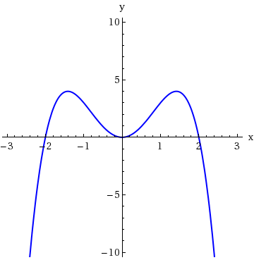 | 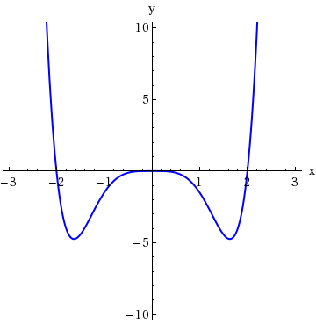
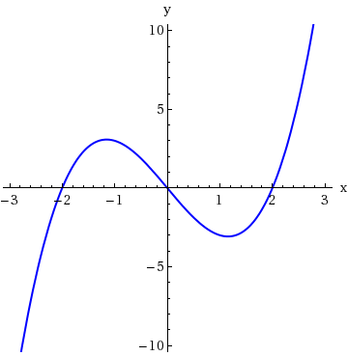 | 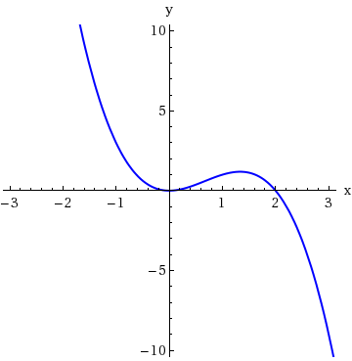
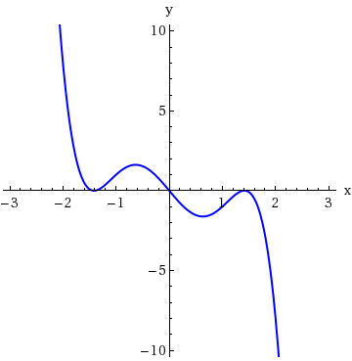 | 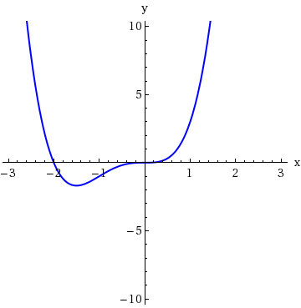

2.
[–/1 Points]DETAILSSPRECALC7 3.2.015.
MY NOTES
PRACTICE ANOTHER
Sketch the graph of the polynomial function. Make sure your graph shows all intercepts and exhibits the proper end behavior.
P(x) = (x − 1)(x + 4)
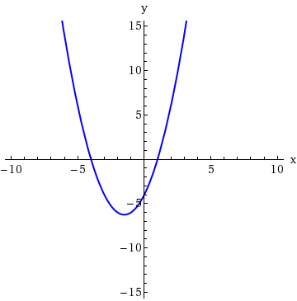 | 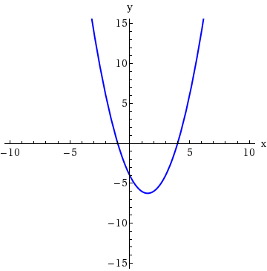
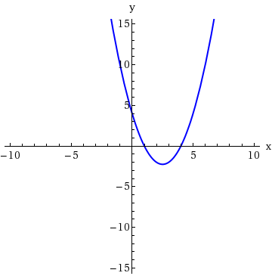 | 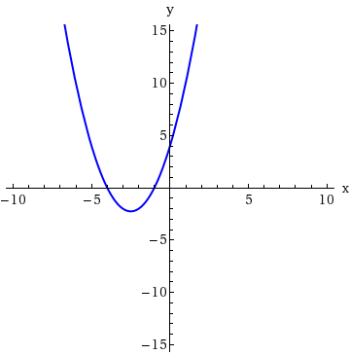

3.
[–/2 Points]DETAILSSPRECALC7 3.2.033.MI.
MY NOTES
PRACTICE ANOTHER
Factor the polynomial and use the factored form to find the real zeros. (Enter your answers as a comma-separated list. Enter all answers including repetitions.)
P(x) = −x³ + x² + 6x
x =

Sketch the graph.
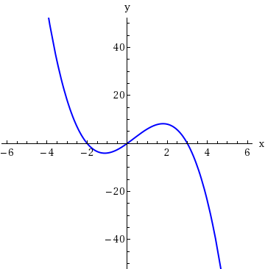 | 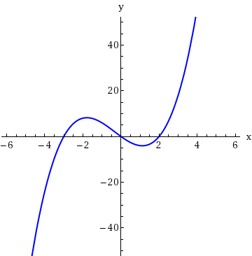
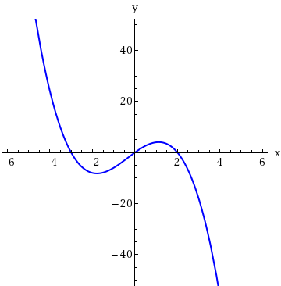 | 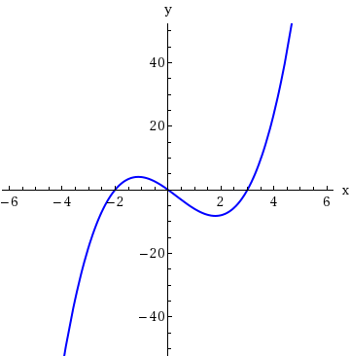

4.
[–/2 Points]DETAILSSPRECALC7 3.2.034.MI.
MY NOTES
PRACTICE ANOTHER
Factor the polynomial and use the factored form to find the real zeros. (Enter your answers as a comma-separated list. Enter all answers including repetitions.)
P(x) = −3x³ − 2x² + x
x =

Sketch the graph.
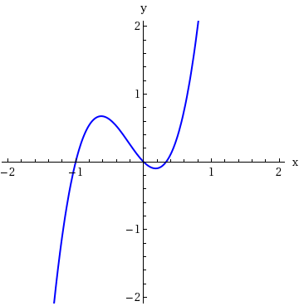 | 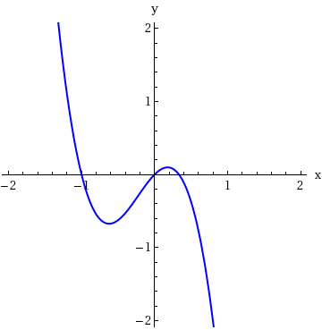
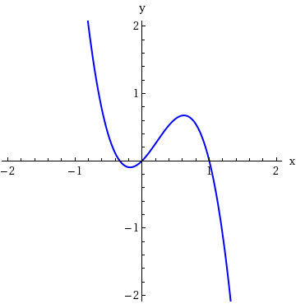 | 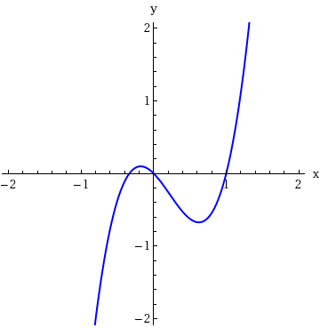

5.
[–/2 Points]DETAILSSPRECALC7 3.2.035.MI.
MY NOTES
PRACTICE ANOTHER
Factor the polynomial and use the factored form to find the real zeros. (Enter your answers as a comma-separated list. Enter all answers including repetitions.)
P(x) = x⁴ − 3x³ + 2x²
x =

Sketch the graph.
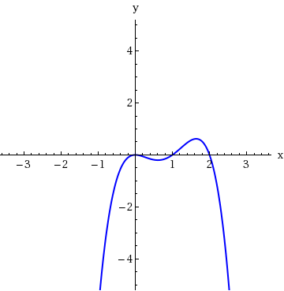 | 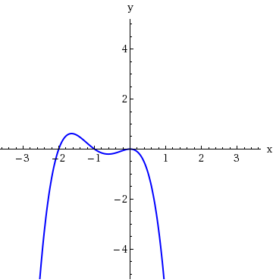
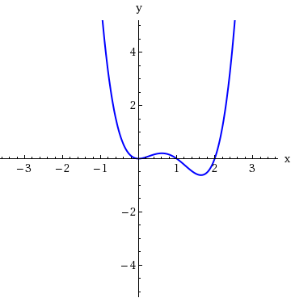 | 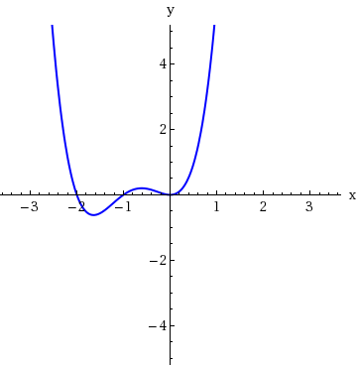
List all possible rational zeros given by the Rational Zeros Theorem (but don't check to see which actually are zeros). (Enter your answers as a comma-separated list.)
Q(x) = x⁴ − 9x³ − 8x + 10
x =

2.
[–/1 Points]DETAILSSPRECALC7 3.4.007.
MY NOTES
PRACTICE ANOTHER
List all possible rational zeros given by the Rational Zeros Theorem (but don't check to see which actually are zeros). (Enter your answers as a comma-separated list.)
R(x) = 2x⁵ + 2x³ + 3x² − 6
x =

3.
[–/1 Points]DETAILSSPRECALC7 3.4.009.MI.
MY NOTES
PRACTICE ANOTHER
List all possible rational zeros given by the Rational Zeros Theorem (but don't check to see which actually are zeros). (Enter your answers as a comma-separated list.)
T(x) = 9x⁴ − 3x² − 17
x =

4.
[–/1 Points]DETAILSSPRECALC7 3.4.003.
MY NOTES
If c is a real zero of the polynomial P, then all the other zeros of P are zeros of
P(x)/(x − c).

TrueFalse

5.
[–/1 Points]DETAILSSPRECALC7 3.4.004.
MY NOTES
If a is an upper bound for the real zeros of the polynomial P, then −a is necessarily a lower bound for the real zeros of P.
TrueFalse
SPRECALC7 3.3.015.MI.
MY NOTES
PRACTICE ANOTHER
Find the quotient and remainder using long division.
x² − 3x + 6
x − 2
quotient
remainder

2.
[–/2 Points]DETAILSSPRECALC7 3.3.016.
MY NOTES
PRACTICE ANOTHER
Find the quotient and remainder using long division.
x³ + 8x² − x + 1
x + 9
quotient
remainder

3.
[–/2 Points]DETAILSSPRECALC7 3.3.017.
MY NOTES
PRACTICE ANOTHER
Find the quotient and remainder using long division.
4x³ + 2x² − 2x − 5
2x + 1
quotient
remainder

4.
[–/2 Points]DETAILSSPRECALC7 3.3.018.MI.
MY NOTES
PRACTICE ANOTHER
Find the quotient and remainder using long division.
x³ + 4x² + 5x + 4
4x + 8
quotient
remainder

5.
[–/2 Points]DETAILSSPRECALC7 3.3.019.
MY NOTES
PRACTICE ANOTHER
Find the quotient and remainder using long division.
x³ + 2x + 1
x² − x + 3
quotient
remainder

